IMPERIAL COLLEGE LONDON

BSc and MSci DEGREES – JANUARY 2014, for Internal Students of the Imperial College of Science, Technology and Medicine

This paper is also taken for the relevant examination for the Associateship

ADVANCED CHEMISTRY THEORY IIA

Organic Chemistry

Monday 13th January 2014, 09:30-11:45

PLEASE NOTE THAT IT IS DEPARTMENTAL POLICY THAT THESE EXAM QUESTIONS MAY REQUIRE UNDERSTANDING OF ANY PRIOR CORE COURSE.

USE A SEPARATE ANSWER BOOK FOR EACH QUESTION. WRITE YOUR CANDIDATE NUMBER ON EACH ANSWER BOOK.

Year 2/0114 Turn Over

2.O1 – Organic Synthesis Part 1

Q1. Answer ALL parts of this question.

- Define ‘regioselectivity’ with reference to a suitable example of a C-C bond forming reaction.

(3 marks)

- Propose the missing reagents required to carry out TWO of the transformations
i) to iii) below. In each case you can assume the reaction is worked up with a source of aqueous H⁺ followed by extraction to isolate the desired organic product. Provide a mechanism for the formation of the product and identify any selectivity features involved in the reaction.

(5 marks each)

i)

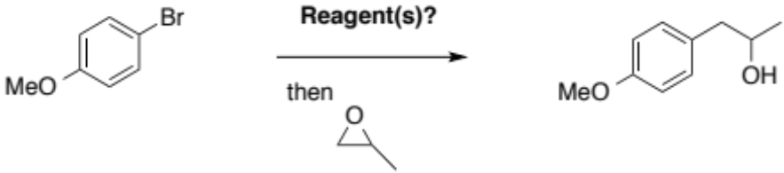

ii)

iii)

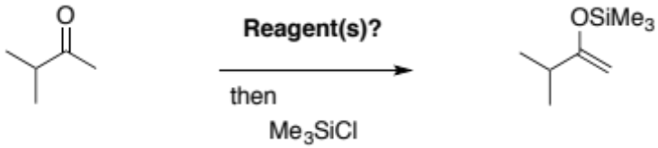

QUESTION CONTINUED OVERLEAF

- For the synthesis sequence shown below:

- Provide structures for the lettered intermediates A, B and C.
- Provide a mechanism for the formation of A and comment on any issues of selectivity.
- Provide a mechanism for the transformation of B to C.

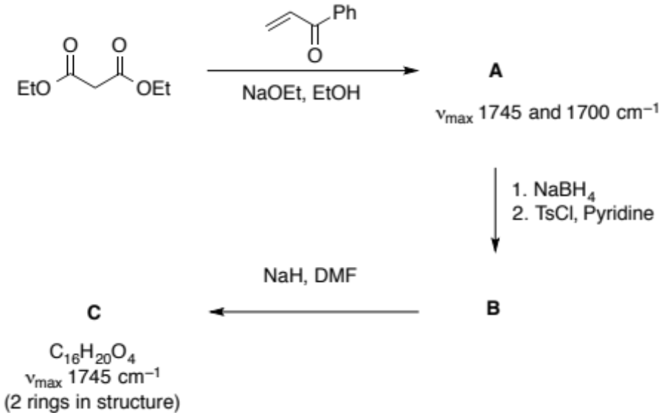

(12 marks; 6 marks for part i; 6 marks for ii/iii)

2.O1 – Organic Synthesis Part 1

Q2. Answer BOTH parts of this question.

- Suggest reagents to carry out TWO of the following transformations. In each case, explain the key mechanistic features that lead to any selectivity that is required.
(6 marks each)

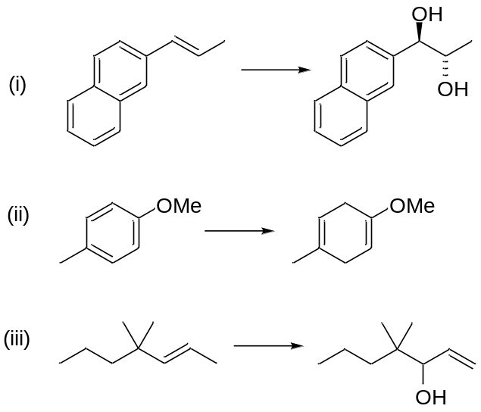

QUESTION CONTINUED OVERLEAF

- In the synthetic sequence shown below:

- Suggest a structure for B and comment briefly on any selectivity in its formation (mechanism not required).
(3 marks)

- Suggest a structure for C and give a mechanism for its formation, explaining any selectivity.
(5 marks)

- Suggest a structure for E (mechanism not required).
(2 marks)

- Suggest a structure for F and give a mechanism for its formation from E.
(3 marks)

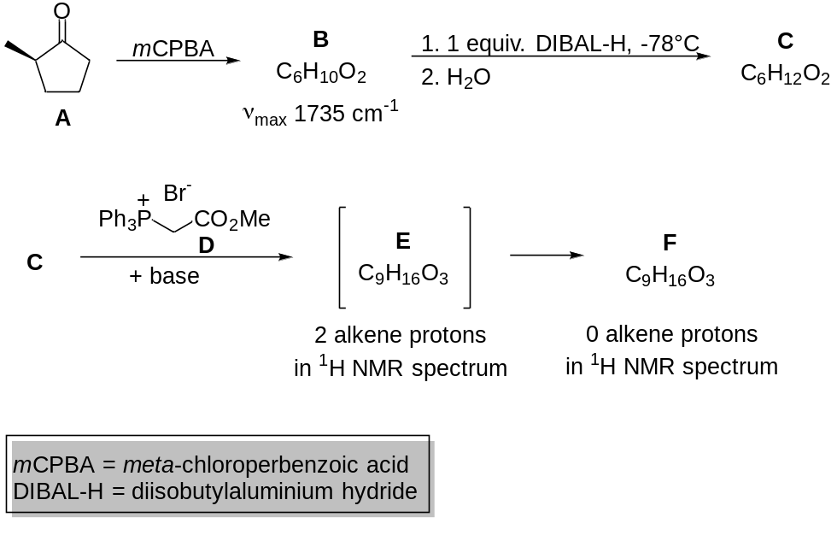

2IS.2 – Introduction to NMR and EPR Spectroscopy

Answer part a) and EITHER part b) OR part c) of this question

- Answer ALL parts of this question.

- Give a brief definition of the following terms:
- Boltzmann distribution
- Spin angular momentum
- Zeeman interaction (6 marks)
- Explain why the ¹H NMR chemical shift of the protons of the methylene group is -0.5 ppm in the structure below. What is the approximate chemical shift of the protons directly attached to the aromatic ring?
(2 marks)
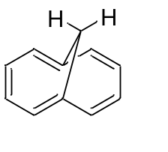
- The molecule below exhibits an unusual long range ⁹J (0.4 Hz) coupling between H_{a} and H_{b}. Explain what structural feature causes this effect. Describe the splitting pattern for the methyl and methylene groups.
(2 marks)
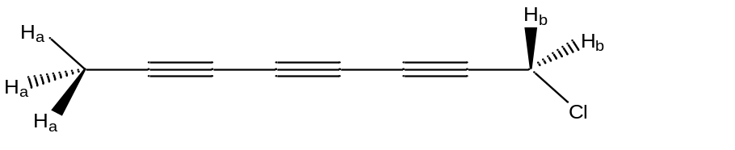

- Which of the protons in the molecule below are magnetically equivalent? Draw the splitting pattern and estimate the chemical shift for H_{a} and H_{b}.
(2 marks)
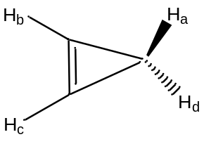

QUESTION CONTINUED OVERLEAF

- Give three advantages of using higher magnetic fields in NMR spectroscopy.
(2 marks)

- Propose the structure of the molecule, C₁₃H₁₈O₂, which has the following ¹H NMR spectrum:

Chemical Shift (ppm) | Multiplicity | Integration | J Coupling (Hz)
0.89 | d | 6H | 6.9
1.49 | d | 3H | 7.1
1.84 | m | 1H | 6.9, 7.0
2.44 | d | 2H | 7.0
3.07 | q | 1H | 7.1
7.07 | d | 2H | 6.5
7.21 | d | 2H | 6.5
12.1 | broad s | 1H | -

The ¹³C NMR spectrum shows 181.4, 140.9, 137.0, 129.5, 127.4, 45.1, 45.0, 30.3, 22.5, 18.2, DEPT-135 shows 3 x quaternary carbons, 6 x CH, 1 x CH₂, 3 x CH₃ and infra-red stretching peaks at 1721cm⁻¹ and 3200cm⁻¹. Give a brief explanation for your proposed structure.
(s=singlet, d=doublet, dd=double doublet, t=triplet, q=quartet, m= multiplet, bd=broad)
(4 marks)

- Answer BOTH parts of this question.

- What is the approximate chemical shift and splitting pattern for all protons up to and including ⁴J?
(3 marks)
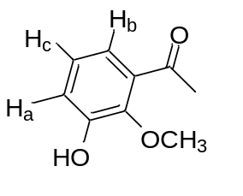

QUESTION CONTINUED OVERLEAF
- What is the approximate chemical shift and splitting pattern for all protons up to and including ³J?
(4 marks)

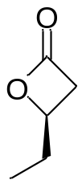
- Answer BOTH parts of this question.

- What is the approximate chemical shift and splitting pattern for all protons up to and including ³J and including any significant ⁴J couplings?
(4 marks)

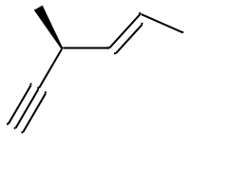
- What is the chemical shift and splitting pattern for H_{a} up to and including ⁴J? Explain why the ¹H NMR spectrum exhibits fewer resonances at higher temperature.
(3 marks)

